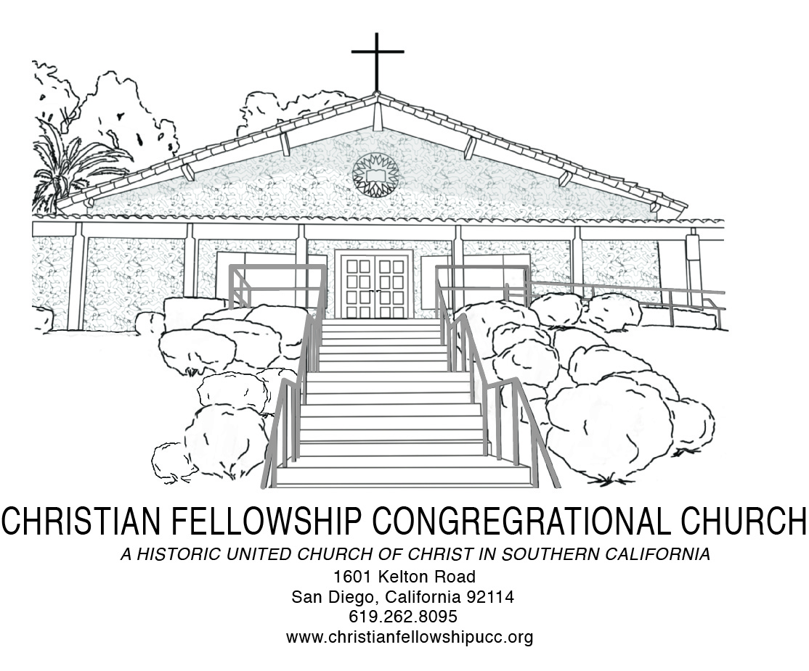
Worship Notes
Harriett Martineau once said, "We do not believe in immortality because we can prove it, but we try to prove it because we cannot help believing it."

To be certain, there are things in science that we do not believe because we can prove them, yet there is an endless pursuit to keep trying to prove them because we cannot stop believing in them. This week with the emergence of the first-ever image of a black hole--our global scientific community brought forward “proof,” from over 55 million light years away, of a belief they have been trusting since Einstein first articulated it in 1915. That image, what scientists called the most mysterious object in the universe, of deep darkness surrounded by a ring of light made possible by dust caught by flames, excited the global scientific world and provoked my faith. I’ve reconciled in some ways that my faith in God is a bit like their years of research and study—a relentless pursuit, driven not by ability to provide proof but by deep belief. This “faith” solidifies my hope and encourages me to keep trying, especially when others doubt, and perhaps one day if I keep at it the universe will open up a horizon in a unique way and offer the “proof” that is sorely needed.

Special Requests for Intercessory Prayer:
Aary Armstrong, Virginia Baptiste, Janice Bellinger, Irene Clayton, Elizabeth Cook, Everett Cruddup, Yvonne Gaffney, Don Gray, Helen Harris, John Johnson, Doris Lewis, Theo Logan, Margaret Neal, Odessa Polk, Winifred Scott, Benjamin Shaw, Ace Thomas, Sammie Williams and Bobby Wilson

Throughout The Week
Sunday 9:00 AM Adult Christian Education Every
10:30 AM Traditional Worship Every
3:30 PM Handbell Choir Rehearsal Every
5:00 PM Jazz Vespers Every
Tuesday 6:00 PM Trustee Board First
6:30 PM Church Council Second
6:00 PM Social Justice Ministry Board Third
6:00 PM Diaconate & Evangelism Board Fourth
Wednesday 5:45 PM Fellowship Meal and Pastor’s Bible Study Every
Thursday 6:00 PM Mission & Stewardship First
6:00 PM Sanctuary Choir Rehearsal Every
Friday 9:00 AM San Diego Food Bank First
Saturday 9:00 AM Women’s Ministry First
11:00 AM Christian Education Board First
9:30 AM Men’s Ministry Fourth
9:00 AM Usher Board Fifth

Christian Fellowship Congregational Church of San Diego (UCC)
1601 Kelton Road, San Diego, California 92114 | 619-262-8095| 619- 940-6828 (Dr. Hill)
www.christianfellowshipucc.org

April 14, 2019, 10:30 A.M.

Palm Sunday

Dr. J. Lee Hill, Jr., Senior Pastor | Gloria Daviston, Deacon

MISSION STATEMENT

We are a Bible-based, progressive and inclusive community of believers,

growing in faith, love and service to God, the community, and the world.

ACCESSIBLE TO ALL | OPEN and AFFIRMING
~ GATHERING FOR WORSHIP ~
*PROCESSIONAL
Soon And Very Soon

*CALL TO WORSHIP
Hosanna! Hosanna! Blessed is the one who comes in the name of the Lord.
Hosanna! Hosanna!

On this day we remember that Jesus entered the holy city of Jerusalem and in triumph was proclaimed King of kings by those who spread their garments and palm branches along the way.
Hosanna! Hosanna!

Let these branches be for us signs of Christ’s victory. May we hail Jesus as our King and follow him in the way that leads to eternal life.
Hosanna! Hosanna!

Humble and riding on a donkey, we greet our Savior.
Hosanna! Hosanna!

We are here to celebrate and worship the King. Hosanna in the highest heaven!
Hosanna! Hosanna!

*INVOCATION AND LORD’S PRAYER
Using: “…and forgive us our debts, as we forgive our debtors… ”

*GATHERING HYMN
“All Glory, Laud, and Honor” No. 226 AAHH

WELCOME & WEEKLY ANNOUNCEMENTS

~ RESPONDING IN FAITH ~

MUSICAL SELECTION
“Hossanna”
CHILDREN’S SERMON
MISSION MOMENT

TITHES and OFFERINGS

LITANY OF DEDICATION AND PRAYER
ONE LORD, ONE FAITH, ONE BAPTISM
An African American Ecumenical Hymnal

*PASSING OF THE PEACE

PASTORAL PRAYER

CHORAL PRAYER RESPONSE

~ LISTENING FOR GOD’S WORD ~
PRAYER OF ILLUMINATION
HEBREW BIBLE READING: Psalm 118:25-29
NEW TESTAMENT READING: Matthew 21:1-17
MUSICAL SELECTION
“I Know Something About That Name”

SERMON
“Singing & Second Lining”

~ DEPARTING TO SERVE ~
*DEPARTING HYMN
“Take the Name of Jesus” No. 297 AAHH

*BENEDICTION

CHORAL BENEDICTION

“As You Go Tell The World”

*Please rise in body and/or in spirit as you are able.
~Assistive hearing devices are available. Please see an Usher for assistance.

