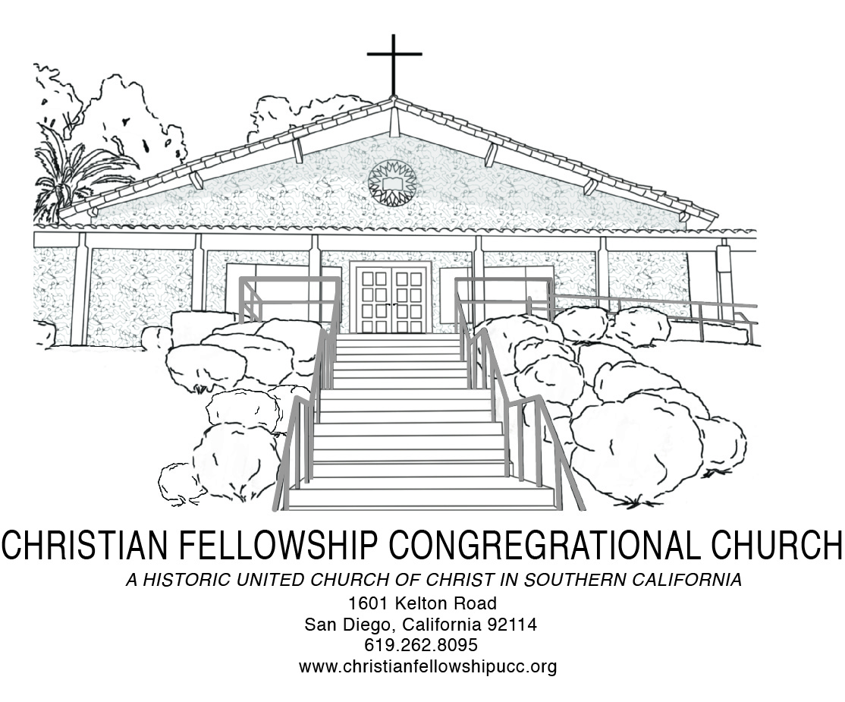
Worship Notes

One of the things that can helpfully be examined during Women’s History Month is the emergence of what is known as Womanist Theology. This approach to biblical analysis, theological reflection, and ethical and practical application rests upon the premise that context should always be a part of Christian proclamation. For womanist theologians, the context is shaped by three factors: race, gender, and class. More precisely, Womanist Theology asks in what ways Scripture can and should be read and applied through the unique socio-cultural position of being an African American woman…What does the Bible have to say to the people and policies that are responsible for the perpetuation of inequities driven by race, gender, and class or income? What does the Bible say to the church in terms of its role and responsibility in addressing and calling for the elimination of any and all disadvantages and forms of discrimination faced by African American women…Womanist Theology as associated with the work of Katie Cannon seeks to make church and society keenly aware of the conditions faced every day by persons that face what Jacqueline Grant called “the tri-dimensional experience” of being a poor, black woman in a capitalist and patriarchal culture where even the black church participates in your marginalization.

-- The Rev. Dr. Marvin McMickle, Crozier Theological Seminary President

Special Requests for Intercessory Prayer:
Aary Armstrong, Virginia Baptiste, Janice Bellinger, Irene Clayton, Elizabeth Cook, Yvonne Gaffney, Don Gray, Helen Harris, John Johnson, Doris Lewis, Theo Logan, Margaret Neal, Odessa Polk, Winifred Scott, Benjamin Shaw, Ace Thomas, Sammie Williams and Bobby Wilson

Throughout The Week
Sunday 9:00 AM Adult Christian Education Every
10:30 AM Traditional Worship Every
3:30 PM Handbell Choir Rehearsal Every
5:00 PM Jazz Vespers Every
Tuesday 6:00 PM Trustee Board First
6:30 PM Church Council Second
6:00 PM Social Justice Ministry Board Third
6:00 PM Diaconate & Evangelism Board Fourth
Wednesday 5:45 PM Fellowship Meal and Pastor’s Bible Study Every
Thursday 6:00 PM Mission & Stewardship First
6:00 PM Sanctuary Choir Rehearsal Every
Friday 9:00 AM San Diego Food Bank First
Saturday 9:00 AM Women’s Ministry First
11:00 AM Christian Education Board First
9:30 AM Men’s Ministry Fourth
9:00 AM Usher Board Fifth

Christian Fellowship Congregational Church of San Diego (UCC)
1601 Kelton Road, San Diego, California 92114 | 619-262-8095| 619- 940-6828 (Dr. Hill)
www.christianfellowshipucc.org

March 31, 2019, 10:30 A.M.

Fourth Sunday in Lent

Dr. J. Lee Hill, Jr., Senior Pastor | Rita Monteiro, Deacon

MISSION STATEMENT

We are a Bible-based, progressive and inclusive community of believers,

growing in faith, love and service to God, the community, and the world.

ACCESSIBLE TO ALL | OPEN and AFFIRMING
~ GATHERING FOR WORSHIP ~
*PROCESSIONAL
Inter In

*CALL TO WORSHIP
In the midst of fear and anger;
In the midst of mayhem and destruction, God calls us.
With everything else going on, who has time for a feast?
We’re busy, we’ll get around to eating eventually.

In the midst of our anxiety, our worry;
In the midst of bill-paying and appointments, God invites us.
We are tempted to just grab a bite, a sandwich between errands,
a snack we can eat while driving, or checking email,
or working on today’s big project.

The feast is spread! All are invited, all are welcome!
We are invited. We are welcome. We are worthy.
Come, let us worship the Lord our God.

*INVOCATION AND LORD’S PRAYER
Using: “…and forgive us our debts, as we forgive our debtors… ”
*DOXOLOGY
CONFESSION
SILENCE
ASSURANCE OF PARDON

*GATHERING HYMN
“Bridegroom And Bride” No. 518 AAHH

WELCOME & WEEKLY ANNOUNCEMENTS
~ RESPONDING IN FAITH ~

MUSICAL SELECTION
“Greatful”

CHILDREN’S SERMON
MISSION MOMENT

TITHES and OFFERINGS
*PASSING OF THE PEACE

PASTORAL PRAYER

CHORAL PRAYER RESPONSE

~ LISTENING FOR GOD’S WORD ~
PRAYER OF ILLUMINATION
HEBREW BIBLE READING: Psalm 43:3-4
NEW TESTAMENT READING: Matthew 25:1-13
MUSICAL SELECTION
“I Give Myself Away”

SERMON
“Between Midnight and Daybreak”

*INVITATION TO CHRISTIAN DISCIPLESHIP
“I’II Say Yes”

~ DEPARTING TO SERVE ~
*DEPARTING HYMN
“Amazing Grace” No. 271 AAHH

*BENEDICTION

CHORAL BENEDICTION

“As You Go Tell The World”

*Please rise in body and/or in spirit.
~Assistive hearing devices are available. Please see an Usher for assistance.

