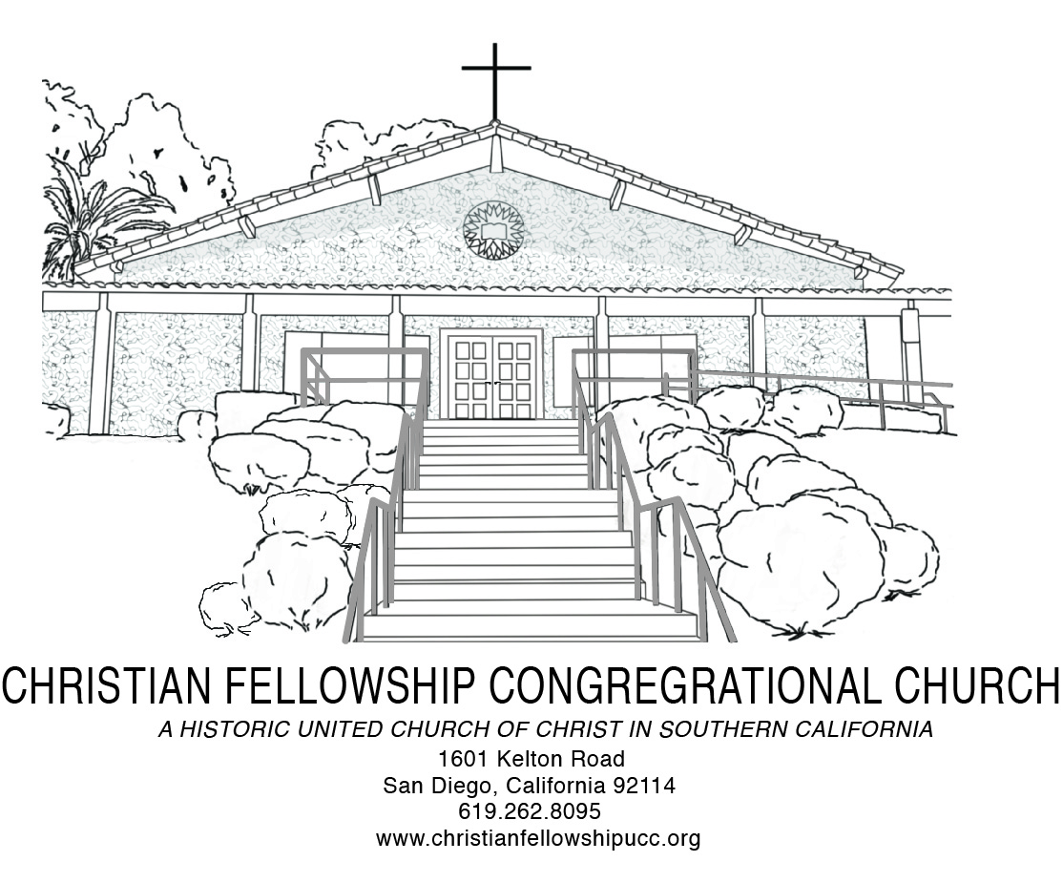
Worship Notes
We are a congregation of the United Church of Christ, a progressive and inclusive, open and affirming, accessible to all, community of believers, growing in faith, love and service to the community and world; our faith is 1,000 years old, but our thinking is not; a place where God is still speaking—and we are attentively listening.
As we prepare in the coming week for Resurrection Sunday we are reminded that resurrection is the mystery that centers and sustains our Christian faith—the faith of more than 2.2 billion people in the world. Without the resurrection there would be no Christianity, no Christendom, no churches, no seminaries, no gospel, no good news. Our faith is a living, breathing, on-going conversation between God, humanity and all of creation in light of the resurrection. Nothing we say or do will make sense, if we cannot boldly proclaim on Easter Sunday: Christ has died, Christ is Risen, Christ will come again. There is no resurrection without a cross, just as there is no divine future in God, without the death-defying power of resurrection in Jesus Christ. While it may be hard to intellectually wrap our minds around the story for which we prepare to celebrate, the story is nonetheless true: A young Palestinian Jew, born to a virgin woman, lived among us. He was God wrapped in human flesh. He was an immigrant peasant healer, a wise teacher of color, a captivating preacher and justice-seeking prophet who humbly gave his life upon the lynching tree of the Roman government. But three days after breathing his last, he picked up the very life he laid down by the power of God—restoring hope and instituting the world’s first, class-action suit against both sin, death and the grave.
Special Requests for Intercessory Prayer:
Aary Armstrong, Virginia Baptiste, Janice Bellinger, Irene Clayton, Elizabeth Cook, Everett Cruddup, Yvonne Gaffney, Don Gray, Helen Harris, John Johnson, Doris Lewis, Theo Logan, Margaret Neal, Odessa Polk, Winifred Scott, Benjamin Shaw, Ace Thomas, Sammie Williams and Bobby Wilson

Throughout The Week
Sunday 9:00 AM Adult Christian Education Every
10:30 AM Traditional Worship Every
3:30 PM Handbell Choir Rehearsal Every
5:00 PM Jazz Vespers Every
Tuesday 6:00 PM Trustee Board First
6:30 PM Church Council Second
6:00 PM Social Justice Ministry Board Third
6:00 PM Diaconate & Evangelism Board Fourth
Wednesday 5:45 PM Fellowship Meal and Pastor’s Bible Study Every
Thursday 6:00 PM Mission & Stewardship First
6:00 PM Sanctuary Choir Rehearsal Every
Friday 9:00 AM San Diego Food Bank First
Saturday 9:00 AM Women’s Ministry First
11:00 AM Christian Education Board First
9:30 AM Men’s Ministry Fourth
9:00 AM Usher Board Fifth

Christian Fellowship Congregational Church of San Diego (UCC)
1601 Kelton Road, San Diego, California 92114 | 619-262-8095| 619- 940-6828 (Dr. Hill)
www.christianfellowshipucc.org

April 7, 2019, 10:30 A.M.

Fifth Sunday of Lent | Holy Communion

Dr. J. Lee Hill, Jr., Senior Pastor | Carmen Miner, Deacon



MISSION STATEMENT

We are a Bible-based, progressive and inclusive community of believers,

growing in faith, love and service to God, the community, and the world.

ACCESSIBLE TO ALL | OPEN and AFFIRMING
~ GATHERING FOR WORSHIP ~
*PROCESSIONAL
“Rejoice”

*CALL TO WORSHIP
As we gather for worship this morning, let us confess what we believe:
We believe that God has revealed Godself as the one who wishes to bring about justice and true peace among people; that God, in a world full of injustice and enmity, is in a special way the God of the destitute, the poor and the wronged; that God calls the church to follow God in this; for God brings justice to the oppressed and gives bread to the hungry; that God frees the prisoner and restores sight to the blind; that God supports the downtrodden, protects the stranger, helps the orphans and widows and blocks the path of the ungodly; that God wishes to teach the church to do what is good and to seek the right…

Let us worship the God of Love, Justice and Mercy.
Let us worship and bless that wonderful name of Jesus!
~based on the 1982 Belhar Confession; born out of the struggle against apartheid in South Africa.

*INVOCATION AND LORD’S PRAYER
Using: “…and forgive us our debts, as we forgive our debtors… ”

*DOXOLOGY
*GATHERING HYMN
“I Am Thine” No. 387 AAHH

WELCOME & WEEKLY ANNOUNCEMENTS

~ RESPONDING IN FAITH ~

MUSICAL SELECTION
“Let It Rise”

CHILDREN’S SERMON
MISSION MOMENT

TITHES and OFFERINGS
*PASSING OF THE PEACE
CHORAL CALL TO PRAYER
“Praise Him”

PASTORAL PRAYER

CHORAL PRAYER RESPONSE

“Praise Him”

~ LISTENING FOR GOD’S WORD ~
PRAYER OF ILLUMINATION
HEBREW BIBLE READING: Psalm 98:7-9
NEW TESTAMENT READING: Matthew 25:31 -46
MUSICAL SELECTION
“I Belong To You”

SERMON
“Love, Mercy and Justice”

*INVITATION TO CHRISTIAN DISCIPLESHIP
“Come To Jesus”

DIACONATE OFFERING
*HOLY COMMUNION

~ DEPARTING TO SERVE ~
*DEPARTING HYMN
“Standing On The Promises” No. 273 AAHH

*BENEDICTION

CHORAL BENEDICTION

“Let The Church Say Amen”

*Please rise in body and/or in spirit.
~Assistive hearing devices are available. Please see an Usher for assistance.

