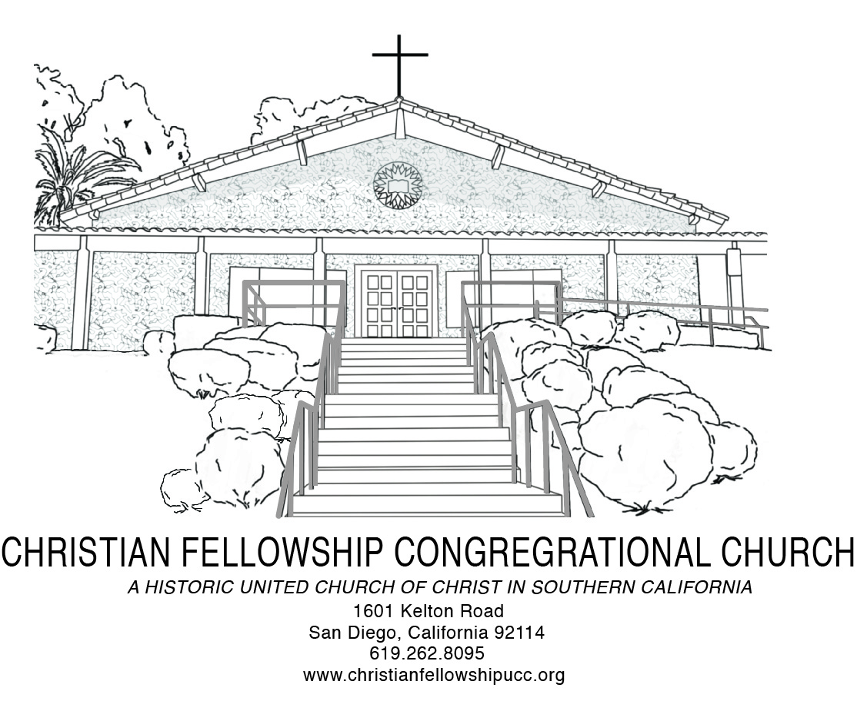
Worship Notes
Howard Washington Thurman

The concern which I lay bare before God today is my need to be better:
I want to be better than I am in my most ordinary day-by-day contacts:
With my friends—
With my family—
With my casual contacts—
With my business relations—
With my associates in work and play.
I want to be better than I am in the responsibilities that are mine:
I am conscious of many petty resentments.
I am conscious of increasing hostility toward certain people.
I am conscious of the effort to be pleasing for effect, not because it is a genuine feeling on my part.
I am conscious of a tendency to shift to other shoulders burdens that are clearly my own.

Special Requests for Intercessory Prayer:
Aary Armstrong, Virginia Baptiste, Verne Campbell, Irene Clayton, Elizabeth Cook, Yvonne Gaffney, Don Gray, Helen Harris, Monica Honore and Israel Bell, John Johnson, Rev. Richard Lawrence, Doris & Charlie Lewis, Theo Logan, Virgel Montgomery, Margaret Neal, Winifred Scott, Benjamin Shaw, Ace Thomas, Flora Vaughn and Bobby Wilson

Throughout The Week
Sunday 9:00 AM Adult Christian Education Every
10:30 AM Traditional Worship Every
3:30 PM Handbell Choir Rehearsal Every
5:00 PM Jazz Vespers Every
Tuesday 6:00 PM Trustee Board First
6:30 PM Church Council Second
6:00 PM Social Justice Ministry Board Third
6:00 PM Diaconate & Evangelism Board Fourth
Wednesday 5:45 PM Fellowship Meal and Pastor’s Bible Study Every
Thursday 6:00 PM Mission & Stewardship First
6:00 PM Handbell Choir Rehearsal Every
6:00 PM Santuary Choir Rehearsal Every
Friday 9:00 AM San Diego Food Bank First
Saturday 9:00 AM Women’s Ministry First
11:00 AM Christian Education Board First
9:30 AM Men’s Ministry Fourth
9:00 AM Usher Board Fifth

Christian Fellowship Congregational Church of San Diego (UCC)
1601 Kelton Road, San Diego, California 92114 | 619-262-8095| 619- 940-6828 (Dr. Hill)
www.christianfellowshipucc.org

February 24, 2019, 10:30 A.M.

Seventh Sunday of Epiphany

Dr. J. Lee Hill, Jr., Senior Pastor | Amani Brinkley, Deacon



MISSION STATEMENT

We are a Bible-based, progressive and inclusive community of believers,

growing in faith, love and service to God, the community, and the world.

ACCESSIBLE TO ALL | OPEN and AFFIRMING
~ GATHERING FOR WORSHIP ~

*PROCESSIONAL
“I’m Glad To Be In His Service”

*CALL TO WORSHIP
Come you who are sadden by life.
A feast is prepared the Bread of Life is drawing near.

Come you who are discomforted by life.
The Healer of all that ails us is drawing near.

Come you who are languishing, wounded and heavy laden with grief.
Earth has no sorrows that heaven can not heal.

*INVOCATION AND LORD’S PRAYER
Using: “…and forgive us our debts, as we forgive our debtors… ”

*DOXOLOGY

*GATHERING HYMN

“When We All Get To Heaven” No. 594 AAHH

WELCOME & WEEKLY ANNOUNCEMENTS

~ RESPONDING IN FAITH ~

MUSICAL SELECTION
“The Storm is Passing Over”

CHILDREN’S SERMON
MISSION MOMENT

TITHES and OFFERINGS
*PASSING OF THE PEACE
CHORAL CALL TO PRAYER
“Thank You Lord”

PASTORAL PRAYER

CHORAL PRAYER RESPONSE
“Thank You Lord”
~ LISTENING FOR GOD’S WORD ~

PRAYER OF ILLUMINATION
HEBREW BIBLE READING: Psalm 95:1-5
NEW TESTAMENT READING: Matthew 14:13-33

MUSICAL SELECTION
“Great is Your Mercy”

SERMON
“Is His Presence Enough”

*INVITIATION TO CHRISTIAN DISCIPLESHIP
“I’ll Say Yes”

~ DEPARTING TO SERVE ~
*DEPARTING HYMN
“I’m So Glad” No. 238 AAHH

*BENEDICTION

CHORAL BENEDICTION

“Let the Church Say, Amen”
*Please rise in body and/or in spirit.
~Assistive hearing devices are available. Please see an Usher for assistance.

