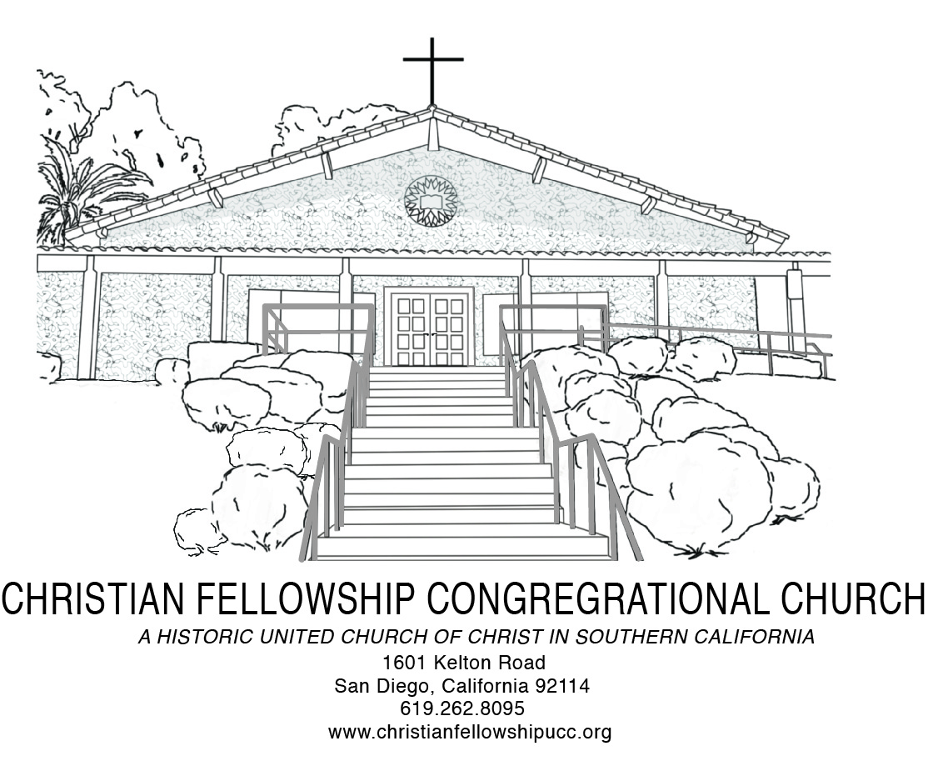
Worship Notes
THE SEASON OF EPIPHANY
The church’s liturgical calendar (Advent, Epiphany, Lent, et.al.) encourages the faithful to pause and meditate on the story of God throughout the year. While it would be nice to remain forever in Advent, at the manger, and hear the angels singing on high—we cannot, like the Magi we must move. The stories that we begin to hear during this new season of the church, Epiphany, reveal to us the Jesus we know—God’s son, Liberator, Way-Maker, God-With-Us. We are challenged in this season to walk the way with God, and see the fullness of God in every human being that we meet. Epiphany is the end of the story of the Nativity, but it is the beginning of the story of Jesus. Epiphany, especially the story of the Magi that we hear today, invites us to reflect on both the threat and promise of the world into which the Christ-child is born. We are invited to consider deeply the restless longing that we are to have if we are to truly build and establish the kingdom of God—a kingdom that stands in stark contradiction to the evil the trumped up Herods of our day devise to destroy God’s hope filled dream for our world.

Special Requests for Intercessory Prayer:
Aary Armstrong, Virginia Baptiste, Barbara Brooks, Verne Campbell, Irene Clayton, Elizabeth Cook, Don Gray, Helen Harris, John Johnson, Rev. Richard Lawrence, Doris & Charlie Lewis, Theo Logan, Margaret Neal, Winifred Scott, Benjamin Shaw and Flora Vaughn

Throughout The Week
Sunday 9:00 AM Adult Christian Education Every
10:30 AM Traditional Worship Every
3:30 PM Handbell Choir Rehearsal Every
5:00 PM Jazz Vespers Every
Tuesday 6:00 PM Trustee Board First
6:30 PM Church Council Second
6:00 PM Social Justice Ministry Board Third
6:00 PM Diaconate & Evangelism Board Fourth
Wednesday 5:45 PM Fellowship Meal and Pastor’s Bible Study Every
Thursday 6:00 PM Mission & Stewardship First
6:00 PM Handbell Choir Rehearsal Every
Friday 9:00 AM San Diego Food Bank First
Saturday 9:00 AM Women’s Ministry First
11:00 AM Christian Education Board First
9:30 AM Men’s Ministry Fourth
9:00 AM Usher Board Fifth

Christian Fellowship Congregational Church of San Diego (UCC)
1601 Kelton Road, San Diego, California 92114 | 619-262-8095| 619- 940-6828 (Dr. Hill)
www.christianfellowshipucc.org

January 6, 2018, 10:30 A.M.

Epiphany Sunday | Holy Communion

Dr. J. Lee Hill, Jr., Senior Pastor | Luci Hopkins, Deacon



MISSION STATEMENT

We are a Bible-based, progressive and inclusive community of believers,

growing in faith, love and service to God, the community, and the world.

ACCESSIBLE TO ALL | OPEN and AFFIRMING
~ GATHERING FOR WORSHIP ~

*PROCESSIONAL
*CALL TO WORSHIP

We gather in the Light that was before, is now, and ever will be.
We see the Light’s ancient wisdom.

We gather in the Light that is God’s continuing gift.
We live into the Light’s new wisdom.

We gather in the Light that is our own, emerging anew each day.
We seek to share this holy wisdom, nurtured in the Light from Bethlehem’s cradle.

God of Light, Love and Justice, in this very moment the star still beckons. Gather us and let the star call us to new ways of healing and hope, restoration and renewal, as we discover again Christ’s call to discipleship and transformation.

*INVOCATION AND LORD’S PRAYER
Using: “…and forgive us our debts, as we forgive our debtors… ”

*DOXOLOGY
*GATHERING HYMN
“Have a Little Talk With Jesus” No. 378 AAHH

WELCOME & WEEKLY ANNOUNCEMENTS

~ RESPONDING IN FAITH ~

MUSICAL SELECTION
“Praise the Lord with Me”

CHILDREN’S SERMON
MISSION MOMENT

TITHES and OFFERINGS
*PASSING OF THE PEACE

PASTORAL PRAYER

CHORAL PRAYER RESPONSE

“So Easy to Love”

~ LISTENING FOR GOD’S WORD ~

PRAYER OF ILLUMINATION
HEBREW BIBLE READING: Psalm 96:10-13
NEW TESTAMENT READING: Matthew 2:1-23
MUSICAL SELECTION
“Lord You’re Holy”

SERMON
“Directed by a Dream”

*INVITIATION TO CHRISTIAN DISCIPLESHIP

DIACONATE OFFERING
*HOLY COMMUNION

~ DEPARTING TO SERVE ~

*DEPARTING HYMN
“Oh How I Love Jesus” No. 291 AAHH

*BENEDICTION

CHORAL BENEDICTION

“Let the Church Say, Amen”

*Please rise in body and/or in spirit.
~Assistive hearing devices are available. Please see an Usher for assistance.

